Introduction for Patient Survey Report :
Clayhill Medical Practice
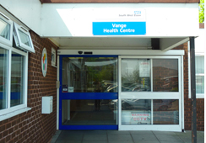Patient Survey Report
2013/14

Patient Satisfaction Questionnaire/Survey 2013-14

The questionnaire for this year was created using the ideas of the Vange Patient Participation Group. The questionnaire created asked open ended questions giving participants an opportunity to elaborate on their answers.
Both Qualitative (Questionnaire) and Quantitative (Statistics) research was used, in order to obtain our findings and ensure they are accurate and correct.
We used the questionnaires to obtain our quantitative findings, which consists of graphs and statistics.

Patient Participation Group

The Patient Participation Group consists of a diverse group of individuals (Ages, Gender & Culture).
This report will be based on our patients involvement and input into the decisions we make as a practice with regards to the services that we have agreed to provide thus ensuring that the quality and standard of care being provided is maintained, along with a range of services to suit our patient community.

This is a pro-active and productive enhancement for our practice, which utilizes the opinions and experiences of the individuals in and around the local area, we are providing services to. Our aim is to get this right for our patients and generally improve our knowledge and the services offered.

The Vange patient participation group was established in 2009 and has been operating for five years, with various dedicated members from the community who are still participating. They are updated/informed in these meetings of any changes happening within a number of organizations such as the NHS, CCG’s, NHS England current news events and CQC issues and involvement which may have an impact on the practice and its services, as well as expressing their own views and queries about current events from a community member’s perspective.

Patients can join the participation group through various lines of enquiry which include:
- Via the receptionist
- Details on the CMP website
- Through various forms of advertisement (Poster and Leaflets which can be found in the waiting room)
- Practice manager interacting with patients
- Word of mouth from patients within the community

We are always keen for patients who are interested to join in, attending meetings and participating within the group. It is crucial for the progression of the practice that patients express their opinions and experiences endured. This gives us as a practice an insight and helps us to make any improvements, commission patient services to the community and progress and evolve as a practice.
We also have a virtual patient representative group advertised on our website: www.clayhillmedicalpractice.nhs.uk with a complete patient group-sign up on line form.
Our patient group consists of: X2 Doctors- this is alternated by each doctor each month, X1 Practice Manager, X7 Patient Participant members from our Medical Practice
We have recently added two more new members both male to this group and one is representative of the health sector as well as working within a care home and will be bringing patients to these meetings to join in.
More are welcome to join, and all of our participants are from varying, diverse backgrounds and cultures.
This is an ongoing process of actively recruiting new members.

Age | Representation | Ethnicity Representation
16-24 years old | X1 member | Black British African
25-34 years old | No representation as of yet
35-44 years old | X2 member | X2 British Asian X2 Black British African
45-54 Years old | X1 member | X1 Black African X1 White British
55-64 Years old | X3 member | X1 Black African X1 White British
65 and over | X3 members | X1 Black African X2 White British

Patient Participation Group DES 2013-2014 meeting dates
Thursday 24th January 2013
Thursday 14th March 2013
Thursday 30th May 2013
No meeting held in August due to School Summer holidays
Thursday 28th November 2013
No meeting held in December due to the Christmas and New Year Holidays
Thursday 30th January 2014
Thursday 27th February 2014

Our Aims & Objectives
- Improved communication between patient and doctor
- Improved services offered at the practice by staff (appointments/queries)
- Improved knowledge of facilities available e.g. Phlebotomy (blood) clinics. Understanding of services offered and available to patients (phone appointments)
- Improve test and treatment explanations so patients have a clear understanding about the process of referrals.

Demographics and Response of patients to the Questionnaire:

The questionnaires were created using knowledge gained from the patient participation group and experiences drawn from last year’s result and review of the questionnaire. We distributed these in November-December 2013. A total of 150 questionnaires were handed out and we received 146 back with 4 missing or not submitted. The targeted criteria for distributing these questionnaires were:

- To try and target both the female and male population
- All different age types
- All different ethnicities
- At different times of the day and not all on the same day
- Throughout the course of a 4 week period

The graphs below represent the demographics or the responses received and the practice population.
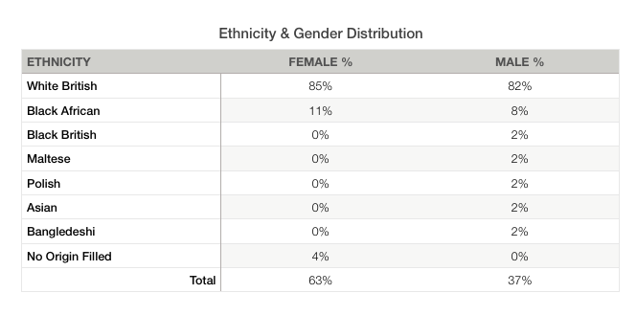

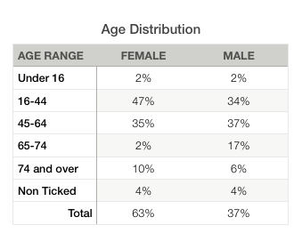

Patient Survey Questionnaire 2013
These were distributed in November -December 2013 and out of 150 given out 146 were received back in total. Please see the figures for the gender distribution, age distribution and ethnicity distribution
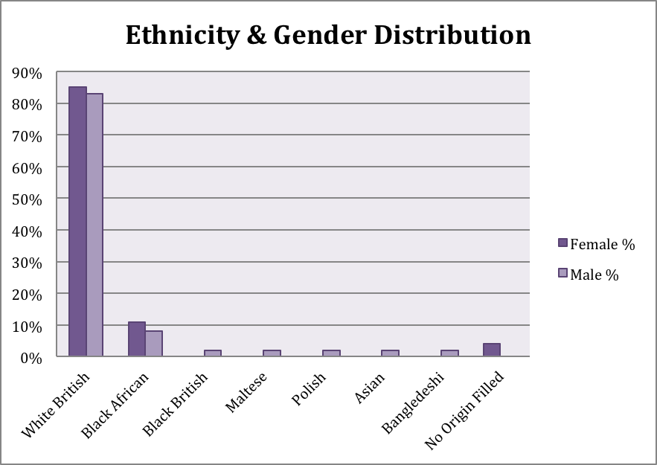

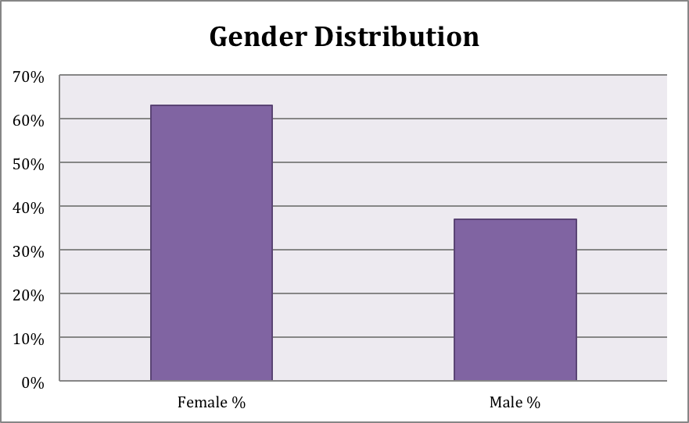

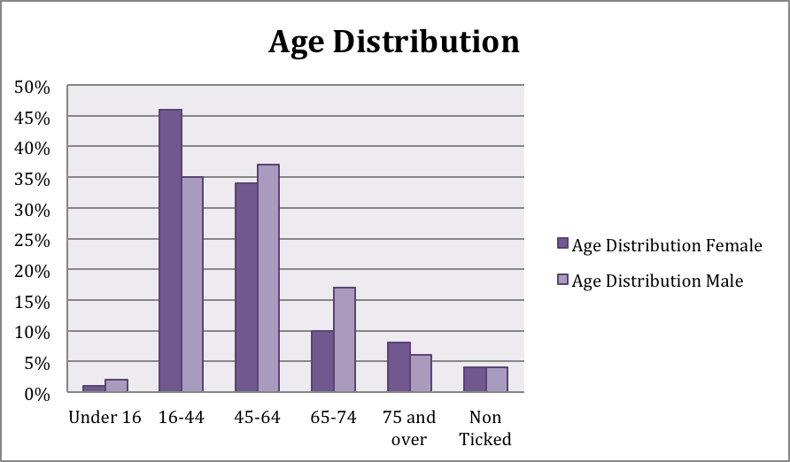

Outcome of comments from the patient survey:
When referring back to last year’s results there has been no great change to the ethnicity though our age groups have changed slightly from 34% for 16-44 year olds to this year over 45%. The category of 45-64 years from 23% last year to this year is over 35% and the 65-74 year old group was 9% now over 15%.

Summary of Patient Satisfaction with the Practice:

Questions asked relating to the practice | Number of Responses | Yes | No | Not Relevant | % Of patients who answered yes
Are you satisfied with practice opening times? | 145 | 132 | 10 | 3 | 90%
Do you find it easy to book appointments? | 145 | 137 | 7 | 1 | 94%
Can you book a routine appointment on the same day or next day (24hrs)? | 144 | 131 | 5 | 8 | 90%
Have you been able to book an appointment at least 4 weeks in advance? | 141 | 57 | 16 | 68 | 39%
Can you book a telephone appointment that is convenient to you? | 142 | 106 | 3 | 33 | 73%
Have you experienced difficulty when requesting a home visit? | 135 | 14 | 36 | 85 | 10%
Do you experience delays while waiting to be seen? | 140 | 72 | 61 | 7 | 49%

Outcome of comments from the patient survey:

The results in this section showed that some of the questions were not relevant to the patient, which explains the lower percentage of people who answered yes. For questions that had a larger number of responses and low numbers of ‘not relevant’ answers the results were encouraging and showed at least a 70-90% positive feedback. This shows the running of the practice is more than satisfactory. We are happy with this result but there is always room for improvement, if we have this type of feedback we would like to be aiming for close to 100% patient satisfaction within the Practice.

Detailed Results Gathered from the Patient Survey:

Q1. Are you satisfied with the practice opening times?

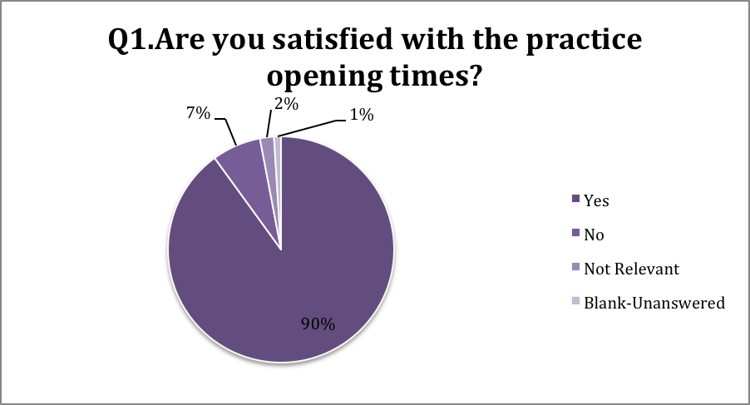

Q2. Do you find it easy to book appointments?

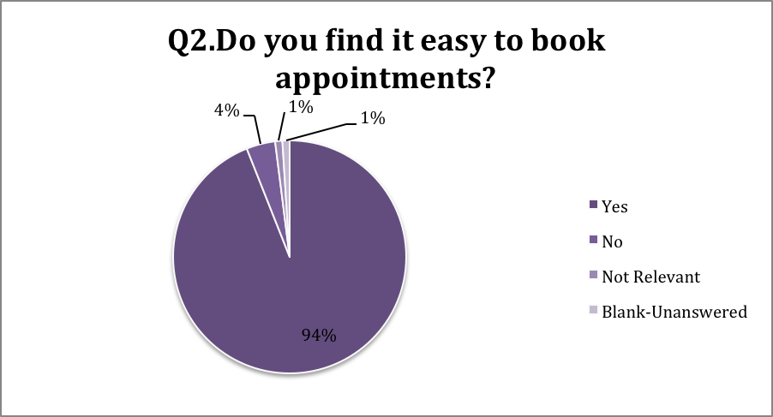

Q4. Can you book a routine appointment on the same day or next day (24hrs)?

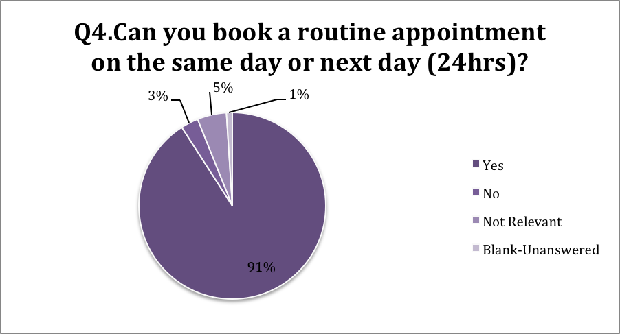

Q6. Have you been able to book an appointment at least 4 weeks in advance?

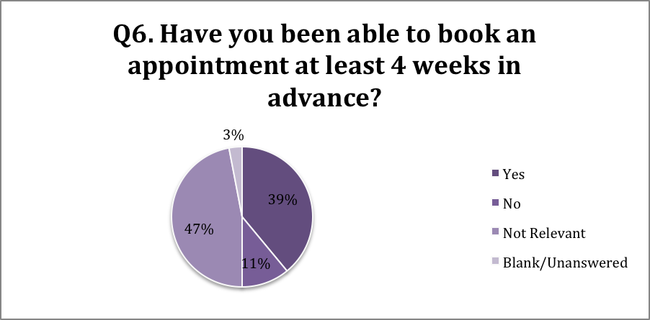

Q9. Can you book a telephone appointment that is convenient to you?

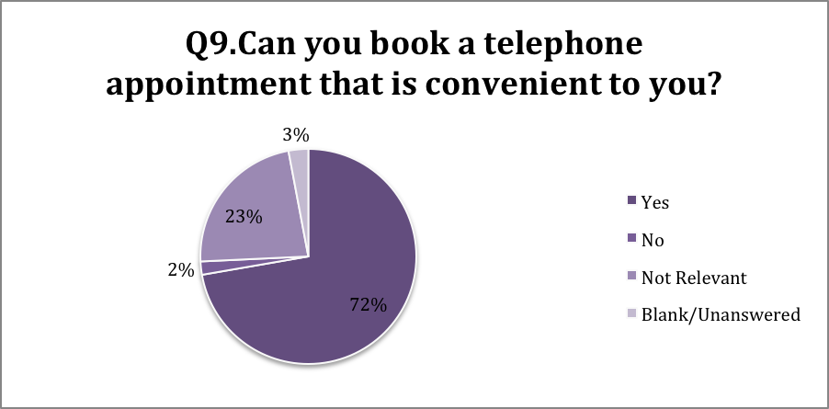

Q10.Have you experience difficulty when requesting a home visit?

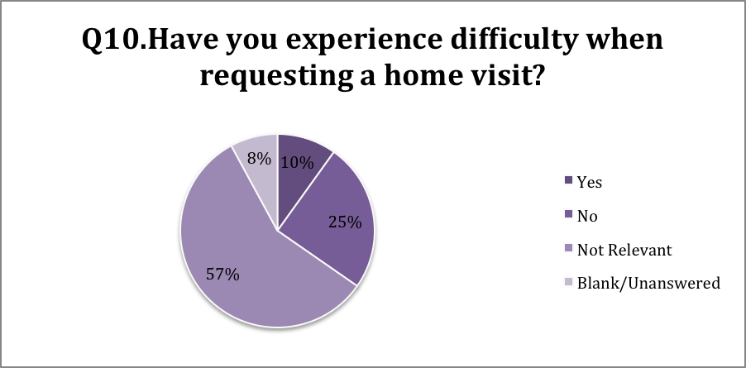

Q11. Do you experience delays while waiting to be seen?

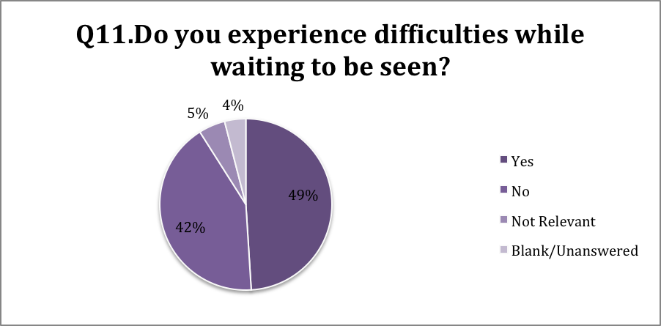

Summary Patient Satisfaction with Staff:

Questions asked relating to the Staff  (Non-clinical) | Number of Responses | Yes | No | Not Relevant | % Of patients who answered yes
Do you find the receptionist staff helpful at the practice? | 139 | 137 | 1 | 1 | 94%
Can you book an extended appointment time with the nurse if needed? | 137 | 61 | 2 | 74 | 42%
Do you see a specialist Practice Nurse for your diabetes? | 137 | 24 | 76 | 37 | 16%
Are you satisfied with your Nurses and Health Care Assistance? | 145 | 133 | 2 | 10 | 91%

Outcome of comments from the patient survey:

The results show that nearly all of the patients who answered the questionnaire are satisfied with the practice staff with over 90% of the patients answering yes. Please refer to feedback comments made by our patients from this survey with regards to our patient staff satisfaction results on the appendix.

Detailed Results gathered from the Patient survey:

Q3. Do you find the receptionist staff helpful at the practice?

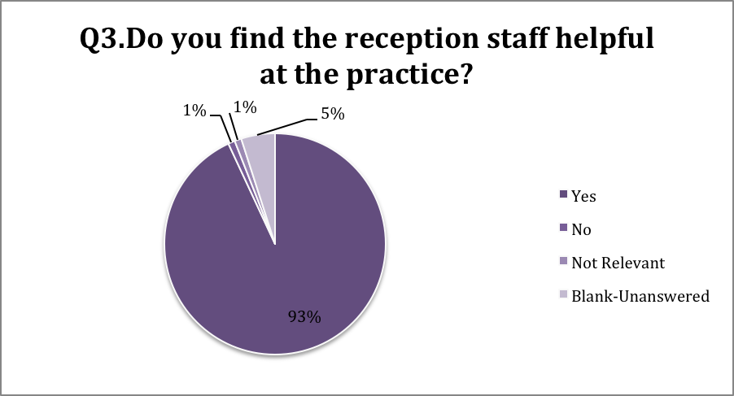

Q8. Can you book an extended appointment with the nurse if needed?

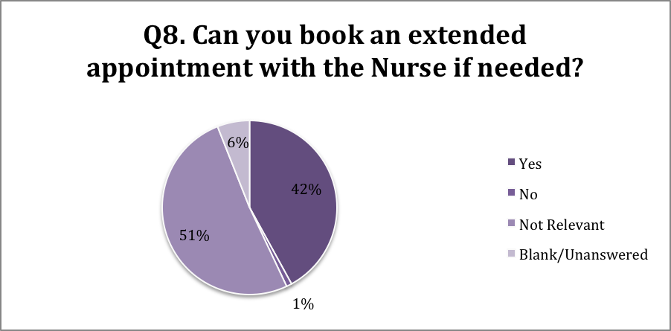

Q13. Do you see a specialist Practice Nurse for your Diabetes?

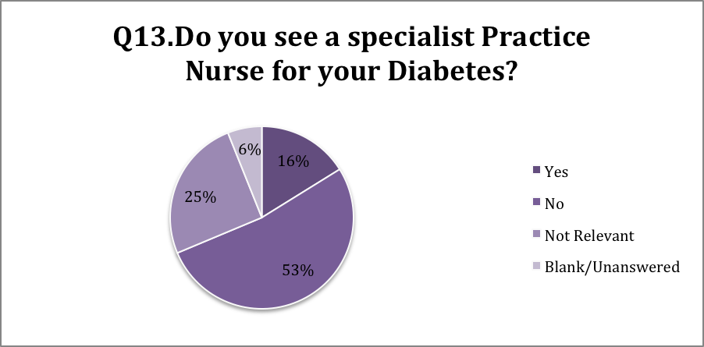

Q19. Are you satisfied with your Nurses and Health Care Assistance?

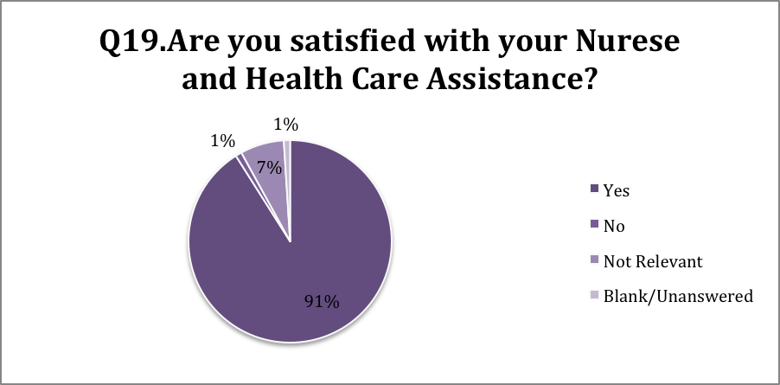

Summary of Patient Satisfaction with Doctors:

Questions asked relating to the Doctors and Nurses | Number of Responses | Yes | No | Not Relevant | % Of patients who answered yes
If you need to see a doctor urgently (Medical Emergency) can you normally get seen on the same day? | 142 | 100 | 11 | 31 | 68%
Can you book an extended appointment time with the doctor if needed? | 138 | 56 | 3 | 79 | 38%
Are you able to see a doctor of your choice? | 139 | 102 | 28 | 9 | 70%
Does your Doctor give you enough time and listen to your problems? | 141 | 110 | 29 | 2 | 75%
Does your doctor explain your tests and treatments and involve you in decisions regarding your treatment? | 141 | 105 | 26 | 10 | 72%
Do you have confidence in the Doctor you see or speak to? | 146 | 115 | 30 | 1 | 79%
Are you satisfied with your doctor? | 145 | 113 | 31 | 1 | 77%

Outcome of comments from the patient survey:

These results are satisfactory with the percentage rate being at least 70 for the majority. The only area, which the percentage rate is below this, is when asked about booking an extended appointment time with the doctor although a high rate of patients said this question was not relevant to them, which would explain why the percentage rate is low. There is room for improvement which clearly show although all together they are of a satisfactory standard. One explanation for this could be because, doctors do not have the time with patients compared to that of the Nurses who build more of a relationship with the patient as they do more of the procedures such as dressing changes, ear syringing, triaging more for the patient then the Doctor therefore a rapport is built much more quickly due to the nature of the appointment with the Nurse. We would like this figure to be closer to 100% so perhaps we need to elaborate on this question as to what reason not 100% overall satisfied. We also need to improve our patient’s awareness of what an extended appointment entails and what it means.

Detailed Results Gathered from Patient Survey:

Q5.If you need to see a doctor urgently (Medical Emergency) can you normally get seen on the same day?

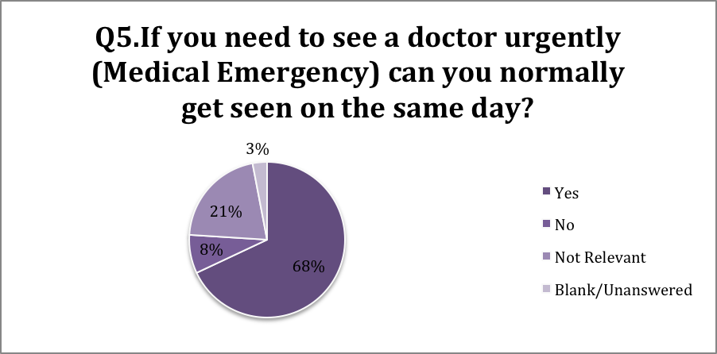

Q8. Can you book an extended appointment time with the doctor if needed?

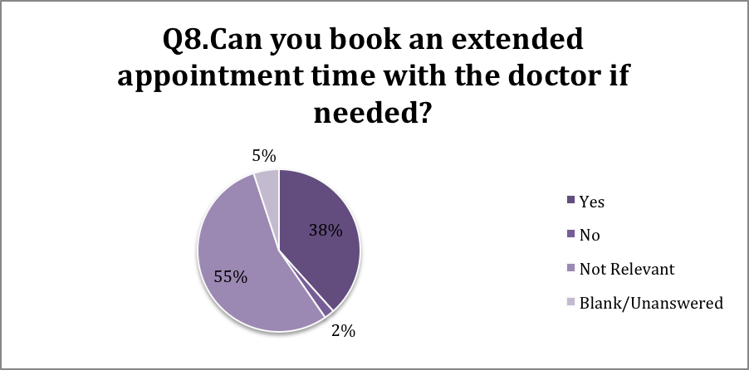

Q14. Are you able to see a Doctor of your choice?

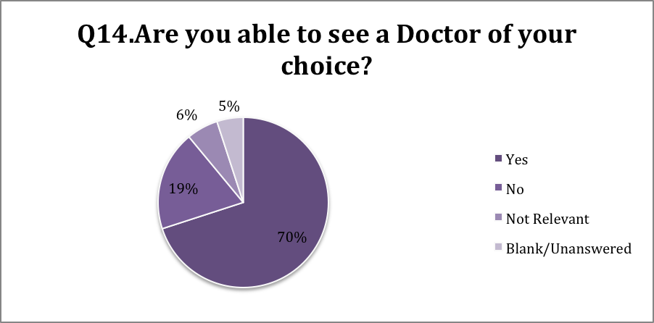

Q15. Does your Doctor give you enough time and listen to your problems?

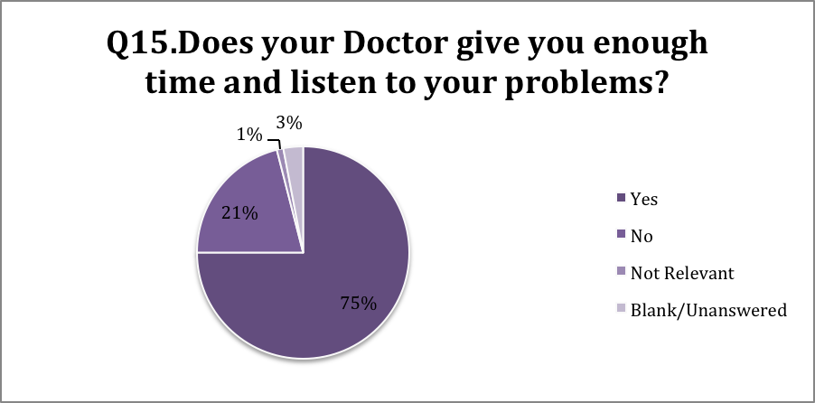

Q16. Does your Doctor explain your tests and treatments and involve you in decisions regarding your treatment?

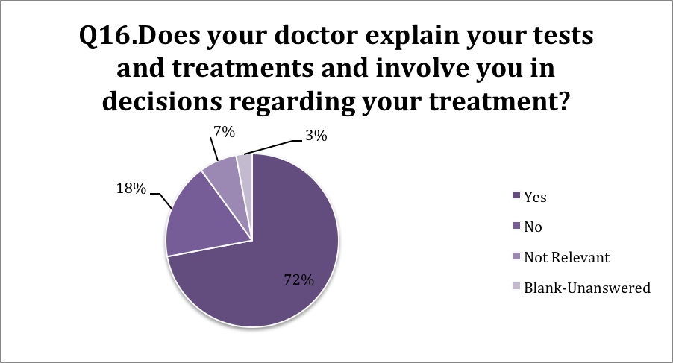

Q17.Do you have confidence in the Doctor you see or speak to?

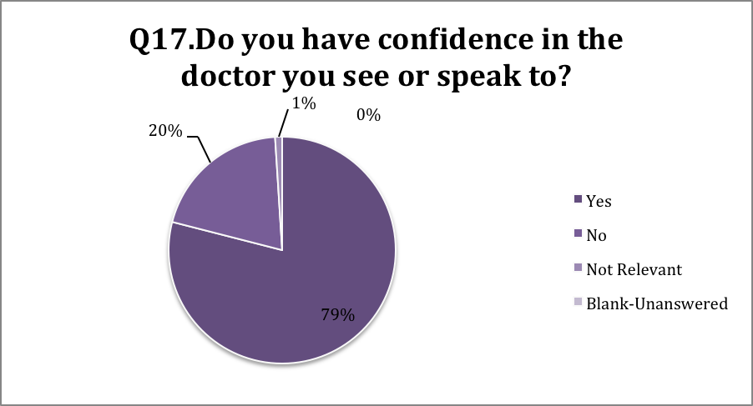

Q18.Are you satisfied with the Doctor?

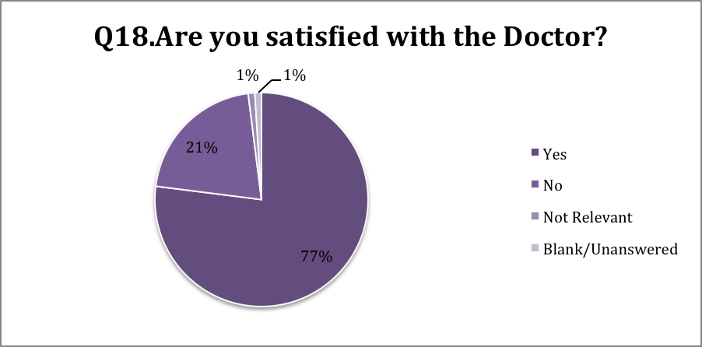
Lifestyle:

Questions Asked Relating to Patients co-morbidities | Number of Responses | Yes | No | Not Relevant | % Of patients who answered yes
Do you have Diabetes, Asthma or suffer from COPD? | 145 | 54 | 82 | 9 | 37%

Outcome of Comments:

When discussing the comorbidities, diabetes, asthma and COPD, could be replaced by the ‘do you need to see a specialist’.
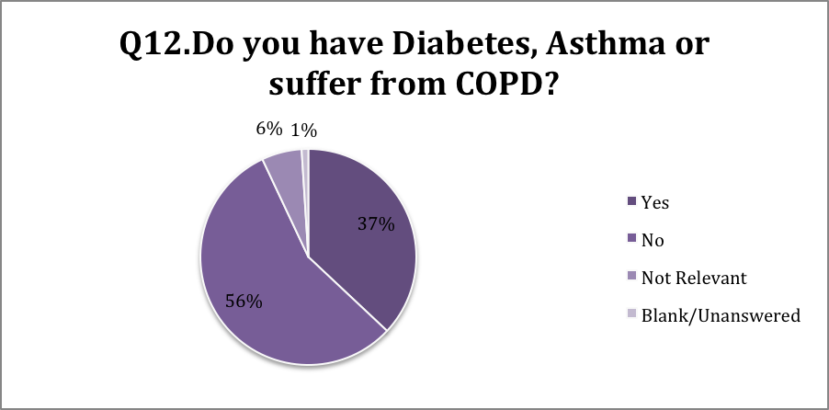

Agreed Action Plan and implementation for 2013-2014-leading into 2015

Topic: | Discussion with PPG | Action | Responsible  lead | Set date  Deadline
1. Patient awareness  & Informatics | Extending appointment slots if needed from 10 min to a 20 min slot  To allow more time to discuss matters concerned | If receptionists query nature of problem or given information voluntarily from the patient.  Receptionist may be able to advise whether a patient needs an extended appointment slot or not, by referring back to the criteria for an extended slot.  To find out if a patient needs this service and to inform the patient on extended appointment slots.  This can be measured by, the number of extended appointment slots given to patients in the month. | Receptionists | This is an on-going process-  Always room for improvement
2. Differentiation of  Extended slots, phone appointments  & home visits | What qualifies as a reason for an extended, phone, home appointment?  When to allocate more time for an appointment | A leaflet informing patients about home visits, phone and extended appointment slots  Informing patients of when these are available, type of appointment & when to request an extended appointment slot (Listening and engaging with patients). | Receptionist +  PM | April 2014  On-going and in progress
3. Clinical waiting times & Delays | When doing a survey again to elaborate on questions regarding time factors  Reviewing the percentage of positive answers and then to consider more options | Review appointment times  Causes of delay when waiting for an appointment, frequency of delays why the delays occur  Improve waiting times by looking at all the above aspects. Consider on- call arrangements  Add a patient waiting time form, which the patient can fill in regarding their appointment and duration of wait. | Doctors +  PM | April 2014  On-going and in progress
4. Patient access & online services | Not enough patients booking on-line | To promote and provide this facility  Online access given to all PPG members  Website and via the receptionist  Collect email addresses and send info/web link by email. | Receptionist +  PM | On- going Process
5. Online prescribing  Repeat prescribing | Patients unaware they can do this  Advantageous to people with personal commitments & work, also housebound patients | To promote and facilitate via waiting room notice boards (posters)  Website  Through the PPG  Via the receptionists verbally  Send email reminders | Receptionist + PM | On –going process  (To deliver & tailor to patient’s needs)
6. Practice Website | Cascading down patient awareness & informing them about the Practice-Patient awareness and informatics | Regular updates to the website this includes different events and information about the Practice.  Measuring this by seeing how many hits we obtain on our Practice website-to set this facility up | Receptionist + PM | Regulate and update monthly
7. PPG Promotion &  Advertisement | To involve and increase our member status  Diversify the group more e.g. mothers with children, male participants and carers  Different gender and ethnic backgrounds | To promote and advertise on the website to join  Market the PPG through causes such as the practice website, verbally, word of mouth, advertises through care homes, radio and leaflet.  Aim to increase members by 50% (+5) | PM+ PPG +  Everyone | On- going process
8. Summer Event 2014 | An event that promotes our Practice, what we have to offer, as well as what we do | Please refer to minutes attached in the appendix  To increase awareness of healthy lifestyles and good living through this event with stalls on advice and literature from different departments and services. | PM+PPG +  everyone | July forecast

Overall Comments on Action Plan:

Going through the Survey results we found that overall participants were satisfied with our services offered in general although there were some areas for improvement.
After discussions with the patient participation group and Doctors we were able to create and implement the questionnaire, and come up with questions devised that would be appropriate to better the practice and show the practice where improvements could be made.
Previous year’s action plans discussed, acted upon and implemented years 2011-2012 and years 2012-2013 are attached to the appendix

PPG Main Topic Focus

Two of our Patient Participant group members are also part of the Locality group South East Management Consortia and Arterial.
Our main focus has been the discussion, organisation and implementation of our first summer event held at Clayhill Medical Practice and bringing patients through our doors to promote and advertise the services that we offer at this Practice, as well as getting to know the community around us. We would like to involve all the other services such as local Dentists, pharmacists, and care homes, with services such as the Diabetes team, heart failure team on board (and many others), please refer to appendix for minutes of this event.

Additional Feedback Comments by Patients:
Comments made by our Female Patients
Positive Comments: | Negative Comments:
“Caring Doctors and staff and a good atmosphere”  “The Ladies on reception are lovely and very helpful”  “Staff and Doctors always pleasant and helpful”  “Since changing Doctor I feel better”  “All very helpful at the surgery”  “Fortunately I rarely need to see a GP or nurse.  However my recent experience here has been very good”.  “STAFF FANTANSTIC,BEST RECEPTION STAFF EVER, SO LOVELY AND KIND”  “Reception staff are fantastic and I think the Doctors should have more of their people skills” | “Doctors are uncaring and rude”  “I am not happy with my doctor as I feel she can be very rude and not understanding, doesn’t actually tell you what’s wrong and just prescribes something”  “Sometimes I feel that I don’t have enough time to tell about my problems. I feel silly when I say as I don’t always get a clear answer”  “I have had some issues when I have wanted to change Doctors in the past and when I was discharged with Asthma by a locum Doctor, I wasn’t tested to use the pumps effectively, not explained and this continued for three months before I saw the nurse”  “My Doctor had me waiting 45 minutes past my appointment time, they are a useless doctor that just says your fine and sends you out, dresses inappropriately and wears fake nails-it’s wrong”  “I feel sometimes the Doctor doesn’t give a lot of compassion when it comes to children as a parent you worry and he brushes it off as if nothing –sorry that’s how I feel”  “I have requested to change from male doctor to female doctor 6 months and have not been accepted by the female doctor since”  “If treatments can sometimes be explained better if need be?”  “I had problems here recently, plus being a new member of this Doctors, I want to stay here and hope my health improves with the help of the Doctor”  “I don’t feel the Doctor always listens!”

Comments made by our Male patients
Positive comments: | Negative comments:
“The reception staff are very helpful but sometimes I feel the Doctor could be more helpful!”  “Very good service”  “Very nice people”  “Staff and Doctors are very helpful and good” | “Not happy with one of the Nurses-my choice”  “Answered no to most of the questions –sorry for the negativity”  “Are you satisfied with your Doctor?” – Yes and No

Overall Comments:

There was a discussion as to the amount of choice there was when being asked about ethnicity, the outcome to this debate was that it was down to personal choice on how people interpret this question. We have included our positive and negative comments in the patient survey and will make them available on the website. It would be useful to find a way to let respondents know that the patient questionnaire survey is not to assess personalities or give subjective opinions on the doctors or their lifestyles. It is more about the service and quality of service that our patient’s should be receiving and how we can improve on this if there are any problems. We are looking to learn and reflect from this patient survey and it is a good way to see how we are doing as a service to our patients. We also thank our patients for taking the time to fill these questions in. Also we need to improve patient’s awareness of information and understanding of what services are available for prescribing medication and the various methods of obtaining this, as well as our appointment systems and booking slots. Continue to improve communication between our patients and our practice staff.
Practice Size:

Practice size as of April 1st April 2013 excluding all patients who are 15 and under approximately 5302

Age Group | List size | PPG Members | PPG Members at  Face to face meetings
16-24 | 885 | 1 | 1
25-34 | 914 | 0 | 0
35-44 | 885 | 3 | 3
45-54 | 871 | 2 | 2
55-64 | 683 | 3 | 3
65 & over | 1008 | 3 | 3
Total | 5246 | 12 | 12

As of to date we have our Practice list size of approximately:

- 6623 patients of whom 3356 are male and 3267 are female

Some patients decline in stating their ethnicity

Ethnicity | No. Of patients in this group on your list
White
British | 2537
Any other white background | 226
Mixed
White and Black Caribbean | 26
British Mixed | 388
White and Black African | 25
White and Asian | 6
Any other mixed background | 4
Asian or Asian Mixed
Indian or British Indian | 10
Asian | 15
Pakistani or British Pakistani | 1
Bangladeshi or British Bangladeshi | 11
Any other Asian background | 5
Black or Black British
Black British | 109
Caribbean | 8
African | 36
Any other Black background | 9
Chinese or other Ethnic Group
Chinese | 7
Any other | 8
Not stated | 12

Publication of report and achievements

A copy of this report will be uploaded onto our Practice website and this will be a true and current reflection of the work undertaken with regards to our patient participation questionnaire for this year and as part of the patient participation DES scheme 2013/14 requirements.

This report will also be emailed to our members of the Patient participation Group and then to be discussed at our next meeting

The wider practice population:
Also information of our results of the survey will be displayed on our notice boards in the practice waiting rooms informing them that they can also access this via our practice website to get more in depth information

Brentwood and Basildon clinical commissioning group –our locality manager

To NHS England

To be upload electronically onto our Practice website and send a copy to NHS England by no later than Monday 31st March 2014

Signed and submitted

Name: ---------------------------- Signature: -------------------------------

Title: ------------------------------- Date: ---------------------------------------

Report Completed by Marie Venkatasawmy – Practice Manager

Appendix Contents:

- Vange patients participation group leaflet and flier
- Annual 2013/14 patient survey
- Additional positive and negative feedback comments (Already in report)
- Copy of Minutes from PPG meeting of discussion of patient survey questionnaire (14th March, 28th November 2013, 30th January 2014.
- Copy of action plans 2011-2012 and 2012-2013
- Copy of Minutes of Summer event 2014
- Copy of Patient Participation Constitution
- Photo on front page of report taken and supported by SG

Patient Participation Group current Poster:
CLAYHILLMEDICAL PRACTICE
VANGE PATIENT PARTICICPATION GROUP


BECOME MORE INVOLVED IN YOUR GP PRACTICE

WOULD YOU LIKE TO HAVE YOUR SAY?

MEETING OF THE PATIENT PARTICIPATION

For more information and if you would like to attend please speak to a member of staff at Reception or can email us at:

ClayhillMediccal.Practicef81006@nhs.net

Tel: 0844 387 8595
Fax: 0844 387 8596

NIBBLES WILL BE PROVIDED

 | Patient Survey 2013
 | Please complete this survey to help identify problems encountered regarding appointments
 |  |  |  |  |  |  |  | PLEASE TICK ONE OF THE FOLLOWING
 |  |  |  |  |  |  |  | YES | NO | NOT RELEVANT
 | 1 | Are you satisfied with the Practice opening times?
 | 2 | Do you find it easy to book appointments?
 | 3 | Do you find the reception staff helpful at the Practice?
 | 4 | Can you book a routine appointment on the same day or the
 |  | Next day (24 hours)?
 | 5 | If you need to see a Doctor URGENTLY (Medical Emergency)
 |  | can normally get seen on the same day?
 | 6 | Have you been able to book an appointment at least 4 weeks
 |  | in advance?
 | 7 | Can you book an extended appointment time with the Doctor  If needed?
 | 8 | Can you book an extended appointment time with the Nurse if needed?
 | 9 | Can you book a telephone appointment that is convenient to
 |  | You?
 | 10 | Have you experienced difficulty when requesting a home
 |  | visit?
 | 11 | Do you experience delays while waiting to be seen?
 | 12 | Do you have Diabetes, Asthma, or suffer from COPD?
 | 13 | Do you see a specialist Practice Nurse for you Diabetes?
 | 14 | Are you able to see a Doctor of your choice?
 | 15 | Does your Doctor give you enough time and listen to your
 |  | Problems?
 | 16 | Do you have confidence in the Doctor you see or speak to?
 | 17 | Are you satisfied with the Doctor?
 | 19 | Are you satisfied with the Nurses and Health Care Assistance?
 | Additional Comments:
 | The following questions provide us only with general information about the range of people who have
 | Responded to this survey. It will not be used to identify you, and will remain confidential
 | Are you? |  | Male |  | Female
 | What is your ethnic origin?
 | What is your age group? |  |  |  | Under 16 |  | 16-44 | 45-64 | 65-74 | 75 or over
 | THANK YOU |  | For taking the time to complete this survey. The results will be published on our Practice
 | Website and also on display on the notice board in the waiting area in the Practice by the 31st March 2013
.
.
.
.
.
.
.
.
.
Clayhill Medical Practice
Vange Health Centre
Southview Road
Vange, Basildon
Essex, SS164HD
Tel: 01268 288633
Fax: 01268 282059
NHS
South West Essex
Date: | Thursday 28th November 2013 @ 18:00-1900
Attendees: | Catherine Sackey(PPG Chair), accompanied by Tedros Medhanie  Pamela Binfield-representing the patients  Marie Venkatasawmy- New Practice Manager  Sandy Greensted- Previous Practice Manager
Welcome  Apologies: | To all and introductions around the table, also Clayhill Medical Practice now has a new Practice Manager-Marie Venkatasawmy  Bola Odunlami  Mischa Afedzie-Hayford  Marlene Moura  Kate Akindipi  Tito Githu
Date of next PPG: | Thursday 30th January 2013
Previous minutes of the PPG meeting:
Went through previous minutes of the meeting to see if there were any issues or questions to be raised –all were happy, nothing to add, change but comments made on the patient survey questionnaire-please see below
Patient survey-To finalise amendments proposed by the PPG-working group
We would like to thank Bola and Pam for the work they have put into drafting this patient survey questionnaire. The following amendments were reviewed:

To remove the option of SOMETIME due to the understanding of this and having multiple option boxes to tick-YES and NO will suffice.

SG: Queried the question relating to children and what should this be- went round the table and couldn’t come up with or think of any suitable questions that would be relevant for this type of questionnaire, as is a general patient survey questionnaire and mostly adults would be filling this in at the moment as we are focusing on the services until we get a feel for how this goes down with our patients and what type and age group will be filling these in. We can then improve on this.
There is no need to do anymore more to this as the group feel that we have covered all areas on the questionnaire. SG to re do, revise and update then this will be sent out to the members of the PPG to look at and the next step will be at how to get this out to our patients.

SG: Commented on how we could also send out to our nursing/residential homes for the patients that are registered with us and their could then fill these in and complete on behalf of these patients, to also look up at the list of carers that are in the Basildon community that cater for our housebound patients and to distribute the patient survey questionnaire to them.

Question raised as to what is the difference between a residential and nursing home
SG responded: The differences are that a nursing has patients that will need nursing/clinically relevant care, registered nurses on the staff 24 hours a day to provide regular nursing tasks. Nursing homes can manage more complex needs than residential homes.
A residential home provides accommodation, 24 hour supervision, meals and personal care. District/community nurses and GPs come can come into the home to help with nursing or medical needs

In relation to how many patients the patient survey questionnaire should be distributed to, it was discussed at the last meeting that this should be 600 but to be realistic in providing figures and for calculating all answers so it will targeted at a total of 150 patients and we need to ensure that these 150 patients are from all age groups-young to the older and from all different ethnic backgrounds.

CS: Commented that some people may struggle with the filling in of this questionnaire if it’s too lengthy. It could be that in future the PPG members assist other patients complete the questionnaire, as it is done at by the Billericay PPG members, who go into the practice to help patients complete the questionnaire.

SG: Offered to make name badges which could be reused by PPG members to help identify them when they were in the practice on PPG duty.

CS: Mentioned also that at the last Arterial meeting, it was reported that the term geriatric and elderly had a negative response as older people found it offensive and preferred the word older.

There was a general discussion on how to better frame questions on age and ethnic origin.
There was a query on the meaning of COPD (Chronic obstructive pulmonary disease) and it was decided that the relevant patients will understand the question and respond appropriately.

Patient engagement
Newsletter- CS reported that there no draft yet and showed examples of newsletters which were brief and easy to read. CS suggested that a simple B4 format is used on bimonthly basis and then reviewed later.

Spring 2014 Event:
There was a general discussion on which organizations to involve. Vitality would be ideal as they deal with well being, healthy living and smoking cessation.
Involve more young people to get their ideas on healthy living, including quick nutritious and affordable recipes for when they go away from home.

The event could be useful in recruiting new patients and promote the services within our Practice.
It was agreed that CS and MV (working group) finalise the details including looking at the financial implications and report at the next meeting. If successful, this event could be the first of many engagement activities for the future from this by doing more.

Updates:
CS: Feedback from the Arterial Patient Engagement Group (PEG) at which the Integrated Plan was discussed. Three key elements to the Plan are:
- Single point of referral
- Rapid Access Geriatric Service Clinics

Minutes have been circulated and are available on request.

Members of the Patient and community Reference Group (PCRG) have been appointed. The term of appointment is 18 months and a member commented that given the short term of office, it would be useful if others could understudy for the purposes of stability and business continuity.

NHS/CCG news: CS suggested that MV provides information on new policies or impending issues that will have an impact on Clayhill Medical Practice as well as the NHS structure and CCG’s. There was a general discussion on the recent debate on banning smoking in hospitals.
AOB:
PB: Expressed concerns about the length of wait for blood tests at the hospital and enquired if there were plans to replace the practice Phlebotomist. SG said the service was now available at the practice for an hour and half every morning.
Meeting closed and ended by wishing everyone:

A Happy Christmas and a Happy New Year 2014

Confirmation of the next PPG meeting to take at Clayhill Medical Practice Meeting room on:

Thursday 30th January 2013

Please remember to forewarn us if you cannot attend so we can be aware of how many will be attending, thank you.

.
.
.
.
.
.
.
.
.
Clayhill Medical Practice
Vange Health Centre
Southview Road
Vange, Basildon
Essex, SS164HD
Tel: 01268 288633
Fax: 01268 282059
NHS
South West Essex
Date: | Thursday 30th January 2014 @ 18:00-1900
Attendees: | Marie Venkatasawmy- New Practice Manager  Frank Hlordzi -GP  Pamela Binfield-representing the patients  Marlene Moura  Bola Odunlami  Mischa Afedzie-Hayford
Welcome  Apologies: | To all and introductions around the table, also Clayhill Medical Practice now has a new Practice Manager-Marie Venkatasawmy-introductions to Marlene and Bola  Kate Akindipi  Catherine Sackey – (PPG Chair)  Pat Scutt  Tito Githu
Date of next PPG: | Thursday 27th February 2014
1.Previous minutes of the PPG meeting:
Went through previous minutes of the meeting to see if there were any issues or questions to be raised –all were happy, nothing to add, change but comments made on the Spring 2014 event
Pamela as very kindly offered to liaise with the Heart Failure team in regards to attending this event and promoting their services to our patients.
We will also be involving the group Vitality and smoking-to do a session in regards to smoking cessation
Newsletter- no draft as of yet Catherine and Marie will update PPG with any further progression on this

2.Promoting and advertising the Clayhill Medical Practice PPG
We would like to thank Bola for offering her services in regards to promoting and advertising our once a month PPG Group externally
Bola is a member and community volunteer/presenter for Gateway 97.8 which is a community station with volunteer presenters and members and has offered to put an advert out to all who listen. The Station Manager will help Bola with this. Bola has also offered to promote advertise our PPG at the Children’s Centre as we need to get some young mothers on board as well as our senior citizens and young people
We need to devise a simple leaflet with the minimum information to advertise our PPG with the details of where, when and time with the NHS and Clayhill Medical Practice logo
3.Patient and Community Reference Group (PCRG)
MM: Informed of us of the South Essex Managed Care group is hoping for 4 new members to join, a member from Langdon Hills Health Centre, was elected by the group to attend Reference group and feedback on CCG meetings.
Marlene will then feed back to our PPG
4.CMP Patient survey results discussed-results, outcomes and actions to be taken
We discussed the patient survey results and MV stated that:

A total of 150 patient questionnaires were handed out and our criteria for handing these out were:

- To try and target both the female and male population
- All different age types
- All different ethnicities
- At different times of the day and not all on the same day
- Throughout the course of a 2 week period

Out of a 150 patient questionnaires given out a total of 146 were given back to us, 4 were missing, not given back, went astray.

Going through the patient survey results we found that overall CMP patients were happy with our services in general but there are areas that we could improve.

Patient awareness:
Questions 7 and 8 can you book an extended appointment with the doctor or nurses if needed?
Certain criteria when booking appointment slots was an issue as even in our group when discussing results there were some of us who were not aware of what an extended slot meant Meaning if you needed more time with the doctor or nurses for an appointment due to the nature of the problem you can book another time slot onto your already 10 minute slot giving you 20 minutes instead to discuss your problem and essentially giving you more time to do this as one of our negative comments was that “sometimes I don’t feel that I have enough time to tell about my problem”
Outcome: If receptionist asks what the problem or is given this information voluntarily by the patient and realises that a 10 minutes slot is not enough maybe could advise or broach that will need an extended slot for this type of query with the patient

Questions 8, 9, 10- What an extended time slot means and what a telephone appointment means as well as what qualifies as a home visit as when discussing these question it became apparent that some were not aware that you could book a telephone appointment instead of an actual visit to the doctors if it was a query, test results, medical sick certificates, a talk with the Doctor.
Outcome: An informative leaflet with regards to telephone calls, home visits and extended slots

Question 11- Do you experience delays while waiting to be seen?
72% said yes they do
Outcome: Next time when doing this survey to elaborate on this question with regards to if such a high percentage of yes answered then to add the time factor in- how long did you wait and when seen what was the reason for the wait?

Question 12- Do you have Diabetes, Asthma or suffer from COPD?
Outcome-Could replace this with do you need to see a specialist?

Question 15- Does your Doctor give you enough time and listen to your problem?
Question 7- Can you book an extended appointment time if needed with the Doctor?
Outcome: To combine these two together as one question

Question 17– Do you have confidence in the Doctor you see or speak to?
Question 18- Are you satisfied with the Doctor
Outcome-Same questions to combine together on next patient survey

Question 19- Are you satisfied with the Nurses and Health Care Assistance?
Outcome: Dr Hlordzi was not happy with 91% it needs to be 100%
Doctors do not have the time compared to that of the Nurses, therefore they build more of a relationship with the patient as they do more of the criteria such as dressing changes, ear syringing, triaging more for the patient then the Doctor so a rapport is built much more quickly due to the nature of the appointment with the Nurse.
We would like to this figure to be at 100% maybe need to elaborate on this question as to what reason not satisfied

There was a discussion as to the amount of choice there was when being asked your ethnicity and the outcome to this debate was it is down to personal choice how people interpret this question and how they answer.

DR Hlordzi’s comment was to signpost and make these positive and negative comments available on our website and to thank our patients for taking the time to fill these questionnaires in

CS: Thinks it would be useful to find a way to let respondents know that the survey is not to assess personalities or give subjective opinions on the doctors, their lifestyles. It’s more about the service and quality of the service that they are receiving and how we can improve this if there are any problems. We are looking to learn and reflect from this patient services and it’s a good way to see how we are doing as a service to our patients.

AOB:
MV: Distributed the Basildon and Brentwood CCG newsletter to all who attended

Also cascaded down information on collecting your prescriptions: improving our patient’s awareness of collecting and ordering their medication and the different ways that this can be done
Are you aware that there different options to collect and gain your prescription :

Via the website Practice- coming soon
Post
Box by the reception desk
Via a selected pharmacy of your choice

You can request your medication 3-4 days before you run out and then collect in 2 working days in person
Mandate a local pharmacy to request your medication on your behalf and then collect this from the chosen/selected pharmacy
Post in a self-addressed envelope with your request a week before you are due to run out and we will post your prescription back to you(a week before to allow for post)
Send someone else on your behalf(close neighbour, family-relative, carer) to ask them to collect when ready if you are in a position that you cannot pick up

CS (not present): Wanted MV to mention the new website www.getwellessex.com which is a website that informs the public of Essex of other services apart from the GP and Accident and Emergency that are also available to them as well.
Unfortunately we ran out of time so I have mentioned it in our minutes instead and we can discuss at out next meeting if needed.

Meeting closed

Confirmation of the next PPG meeting to take at Clayhill Medical Practice Meeting room on:

Thursday 27th February 2014
Excluding the months of August and December due to school and Christmas Holidays

Please remember to forewarn us if you cannot attend so we can be aware of how many will be attending, thank you.

.
.
.
.
.
.
.
.
.
Clayhill Medical Practice
Vange Health Centre
Southview Road
Vange, Basildon
Essex, SS164HD
Tel: 01268 288633
Fax: 01268 282059
NHS
South West Essex

PATIENT PARTICIPATION GROUP

Please come and join and share you views with us
We would like to hear from you

Every last Thursday of the month
Our next one is on

Thursday 27th February 2014
@ 18:00-19:00

Venue:
Clayhill Medical Practice
Vange Health Centre
Southview Road
Vange, Basildon
SS16 4HD

.
.
.
.
.
.
.
.
.
Clayhill Medical Practice
Vange Health Centre
Southview Road
Vange, Basildon
Essex, SS164HD
Tel: 01268 288633
Fax: 01268 282059
NHS
South West Essex

Patient appointment times

We try to be as flexible as possible with our appointment slots and are able to offer our patients same day appointments and next day availability depending upon our capacity.

OPENING TIMES
Monday | 08:30-18:30
Tuesday | 08:30-18:30
Wednesday | 08:30-18:30
Thursday | 08:30-18:30
Friday | 08:30-18:30
WEEKENDS
Saturday | CLOSED
Sunday | CLOSED

Our patients have access to the Practice via the telephone and face to face throughout the hours of 08:30-18:30 Monday to Friday except on weekends
Our phones lines are up and running from 08:00 and we open our doors and start clinics from 08:30 onwards.

We have two GP’s Dr Ogunbiyi and Dr Hlordzi and their hours are:

CONSULTING TIMES | MORNING | AFTERNOON
Monday | 09:00-13:00 | 15:50-18:20
Tuesday | 09:00-13:00 | 15:50-18:20
Wednesday | 09:00-13:00 | 15:50-18:20
Thursday | 09:00-13:00 | 15:50-18:20
Friday | 09:00-13:00 | 15:50-18:20
WEEKENDS
Saturday | CLOSED
Sunday | CLOSED

Our extended hours –surgery

We are under the extended hours DES scheme and provide our patients with late night appointments. This is held once a week and is either on a Wednesday or Thursday evening from 18:30-21:45 with one GP alternated by Dr Ogunbiyi and Dr Hlordzi (Pre-booked appointments only) these can be booked via the telephone or face to face via our receptionists.

We have two Practice Nurses and their hours are:

Our Practice Nurses can offer a wide range of services

CONSULTING TIMES | MORNING | AFTERNOON
Monday | 09:00-13:30 | 16:00-18:30
Tuesday | 09:00-13:30 | 16:00-18:30
Wednesday | 09:00-13:30 | 16:00-18:30
Thursday | 09:00-13:30 | 16:00-18:30
Friday | 09:00-13:30 | 16:00-18:00
WEEKENDS
Saturday | CLOSED
Sunday | CLOSED

We have one HCA and their hours are:

CONSULTING TIMES | MORNING | AFTERNOON
Monday | 09:00-13:00
Tuesday | 09:00-13:00
Wednesday | 09:00-13:00
Thursday | 09:00-13:00 | 15:30-18:30
Friday | 09:00-13:00
Weekends
Saturday | CLOSED
Sunday | CLOSED

The Practice offers a Phlebotomy (blood) Clinic which are held week days Monday to Friday from 09:00-11:00am

Out of hours services:

If outside our normal Practice hours you can still call our GP number, but you will be directed to an out-of-hours service which is NHS 111 or 999 for an emergency only. The Out-of-hours’ time is from 6.30pm to 8.00am on weekdays and all day at weekends and on bank holidays.

Booking Appointments:
Please do so via our receptionists face to face or by telephone from 08:30-18:30

- Reception staff can advise on whether you need to see a doctor or nurse depending on the nature of your query/issue

- Depending on the nature of your query/issue you could have a telephone consultation instead of making a visit to the surgery-which could save you time

- For urgent problems you will be seen on the same day

- You can pre-book an appointment up to two months in advance with your GP

- You can only book one appointment per patient and one appointment per problem

- You can extend your appointment time depending on the nature of your query/issue that you have please speak to the receptionists who can advise and help with regards to this if you think you need more time

- Our GP appointments are 10 minute consultation slots only unless you state otherwise

- Please cancel your appointment if it is no longer required as this reduces the amount of did not attend appointments and frees these slots up for other patients to use

We are closed weekends and Bank Holidays

Our opening times are on our website and for more information please go to www.clayhillmedicalpractice.nhs.uk

Action Plan for 2011-2012

Subject matter | Discussion with PPG | Action | Set date  Deadline
1 Access to surgery and availability | Need for improvement in regards to this | Patients can now book appointments on the day or the next working day at the Practice  This was implemented by increasing the embargoed slots + extended the availability of pre-booking appointments in advance | This is an on-going process- always identifying the trends and changes in patients’ needs via the PPG and also patient themselves.
2. Doctors & Nurses clinic times | To increase clinic times | Increased these via the access to the Practice and availability increased and improved from 2011 | This is an on-going task as above watching and identifying the trends and changes of patients’ needs due to life style and work
3 Extended opening times | More demand for late evening rather than a Saturday clinic- due to working weekends & wanting to keep weekends free for relaxation and leisure time | Changed from a Saturday to every other Wednesday or Thursday evening | An on-going task  Yet again being able to identify trends and changes to suit our patients criteria

Action Plan for 2012-2013
Subject matter | Discussion with PPG | Action | Set date  Deadline
1 Posters re booking in advance | Patients that needed to pre book standard appointments for monthly or on-going visits for the Doctor/nurse-Long term ill patients | Can book up to two months in advance | March 2013
2. Patients awareness of Doctor clinic appointment times and duration | To make patients aware of Doctor appointment times-10 minutes only per patient slot | Posters in waiting rooms  All appointment times to be verified to suit reasons for appointments (i.e. NHS health checks 20mins slot) | This is an on-going process
3 Doctors Waiting times | To ensure and inform patients of appointments over running or behind/late | Staff-receptionists to cascade and communicate when clinics are running behind | This is on-going and challenging process
4. Need more patient participation from different areas involved | Young Adults, Mothers with babies, carers | To promote and advertise our PPG verbally and via the website encouraging patient input | This is an on-going process
5. Staff patient survey for next year | Patient survey questionnaire to be smarter and more specific towards problems generated via Practice | PPG input as to what is viable to do this via patients point of view and experiences | March 2013

Date: | Friday 07th March 2014 @ 10:00
Attendees: | Catherine Sackey, CS (PPG Chair)  Marie Venkatasawmy- Practice Manager
Clayhill Medical Practice Spring –Summer event 2014:
On discussing we went through the details of this event and it was decided that the date to be held for this has now been moved from Spring to Summer instead and should be for the duration of 2.5 hours in the morning on the last Saturday of the July school term.
Summer term 2014

- Tuesday 22 April 2014 – Tuesday 22 July 2014

Date to be confirmed

CS/MV: To be the main two in implementing and planning of this event.
This will be the first Clayhill Medical Practice venture so we do need to make it work and be able to follow on from this to maybe make it into an annual event for the local community.
To be held in the waiting room and to also see if can use the health visitors toilets(for patients) and kitchen(for caterer)

Proposed Agenda:
Programme and Presentation:

- 09:30-10:00 catering and stall set up, organising and ensuring everything in place and order
- 10:30 Doctors to meet and greet- to mingle and offer their advice, this would be good to recruit more patients into our practice as long as in our catchment area and this would be a good time promote and advertise our GP services within our Practice
- 11:00 start fun, go round stalls, activities for children story book tellers from the library
- 11:30 seminar indoors- presentation on Clayhill Medical Practice and anyone else who would like to talk about their services to the patients, talk about morality rates in the area
- 12:00- Lunch period and break
- 12:30 To resume if anyone else has any questions and query otherwise will slowly finish and close event

Dancers with drums from the cultural academy in Harlow(Fewar)

Stalls:
- Heart Failure services
- Vitality-Smoking cessation
- Awareness Group-Local sickle cell group
- Diabetes services
- Local Association-Circle to promote and talk about what they do
- Local Chemists- to promote and advertise on prescription services
- Children and young people services-Health visitors
- Juicing stall(smoothies and health drinks)
- Health and beauty- Students that do head massage
- Caterer-Simple menu- finger food/buffet style food, sandwiches, fruit display
- Tombola/raffle –need products for raffle toiletries(body shop), Holland and Barratt-need a raffle ticket book
Involvement and to do list:
CS: To do a draft letter of event then to be put on CMP headed paper to be sent out
CS: To get the Local association group-Circle involved and to advise us on what they do
CS: To speak to Awareness groups such as the local Sickle cell group
CS: To look into having event speakers from different areas come in and give advice and support-The Local churches- Church of England, Methodist, Baptist and the Mosque (Brother Salwa)
CS: To involve the vets down the road
CS: To involve more young people and get their ideas-speak to colleges and approach universities for supporting students when away from home with helping them with ideas for cheap food recipes and how to make these- have demonstrations on this, head massages, healthy living and life style whilst away from home and on their own
CS: To get a sample menu- for simple finger food, buffet style-sandwiches, spring rolls, fruit display
CS: To speak to local library with regards to children story tellers for the morning
CS: To speak and liaise with the dance academy for dancers and drums
SG: To involve the group Vitality-to do a session in regards to smoking cessation
PB: Has spoken to someone with regards to the heart failure team and setting up an information and advice stall
MV: To get the local Dentist down the road involved- already spoken to dental nurse who will speak to their Practice Manager and get them to give Marie a call
MV: Marie spoken to health visitors who are interested and will allow us to use their toilets and kitchen and then to cordon off any no entry exits.
MV: To get Diabetes team phone number and speak to Shelley
CS/MV: To get the local statistics of morality rates and do a presentation about healthy living and lifestyles –to promote good health
PR/LC: To speak to our Local Chemists to see if they are interested in being involved letter to be drafted and sent out –could talk and promote their prescription services, also donate to our raffle
All staff: To decorate with balloons and banners the night before or in the morning
To do a Poster for the event and advertise
To set a date and for May sign off of this event by everyone and get started
Risk Assessment:
MV: To check if can open doors of Practice on a Saturday- insurance and liabilities if we are covered for out of hours, to also speak to Estates
Food Hygiene
MV: To check if okay to do a juicing stall and bring in own electrical equipment for insurance reasons if anything happens, also need to be aware of food allergies( nut .lactose intolerance)

Expenditure:
Dancers and drums from the Cultural Academy in Harlow-Petrol allowance
Vegetables and fruit for juicing
Banners and balloons
Caterer-lunch

CLAYHILL MEDICAL PRACTICE

PPG MEETING THURSDAY 30/05/13
6.00PM
Attended:
- Annie Bailey
- Sandra Greensted
- Dr Hlordzi
- Catherine Sackey
- Mary P Scutt
- Marlene Moura
- Dr F Ogunbiyi

Apologies:
- Bola Olunlami

Non Attendees:
- Kate Akindipi
- Mischa Afedzie-Hayford

New member was welcomed to the group.

Minutes of the last meeting were discussed. Regarding the Patient Survey, Annie explained survey to the new member. Marlene stated that the survey is very good and would be worth asking other surgeries what their surveys are like so as they can compare, to improve upon. Some questions were not helpful. Sandy said that the survey needs to be simple for the patients.

Marlene said to have samples from other surgeries in time for the next meeting, to keep questions simple and target to everyone and their abilities.

Also noted to put on the end of the survey inviting patients to join the PPG

Annie had emailed all patients by mobile texting inviting them to join the PPG, but only had approximately 3 responses.

Election of chairperson

The previous chairperson was Kate Akindipe but she has now stepped down, the group need to agree on a new chairperson. A copy of Terms of Reference is to be emailed to all members.
Catherine Sackay has nominated herself and the other members present have agreed. Annie is to email the other members for their decision.

Everyone in favour of having the newsletter again, as very informative, to have it bi-monthly

CCG Information

Marlene brought a document about the CCG to the meeting; Annie is to email copies to all members. Sandy and Frank explained to the new member what the CCG is.
Marlene commented on the document; spoke about reducing the hospital admissions.
Discussions around Health watch
Information sent to Marlene from Happier.
Marlene to give to Sandy comments regarding CCG Priorities.

Meeting closed 7.20pm- Follow-up meetings arranged 2 monthly last Wednesday of the Month

Patient Participation Group Constitution
How the Patient Participation group runs as a meeting group, how it is held and what it entails:

1.Constitution | The name of the group shall be the Patient Participation Group, hereafter referred to as the PPG.
2.Main Objectives of the Patient Participation Group | - The principal aims and objectives of PPG shall be to improve the communication between the patients and the Practice.  - Strive to improve the services and knowledge of facilities available to patients to represent and further the views of patients.  - The PPG will act at all times without bias in terms of their representation of patients.
3.Membership &  criteria for joining | The Patient Participation Group shall be made up as follows:  - Medical Representatives:  - Two Practice Doctors  - Nursing Staff  - One member of the Administrative Staff  - Patient’s Representatives:  - Three general representatives from among the patient’s electorate.  - One parent of a child under the age of six years.  - One parent of a child between the ages of six – twelve years.  - One parent of a child between the ages of twelve – sixteen years.  - One registered Disabled Patient.  In addition to the above, patients with specialist knowledge of specific disabilities may be co-opted at any time, though such people shall not have any voting rights.  The term of office of the Patients Representatives shall be 3 years.  In the event that a representative no longer fulfils the criteria upon which they were elected they shall retire and a casual vacancy will result.
4.Casual Vacancies | In the event of a casual vacancy arising, steps will be taken to fill the vacant position. Nominations will be sought by way of notices in the surgery. In the event of more than one nomination a secret ballot will be held by members of the committee. The successful candidate will serve the remainder of the period of unexpired tenure and will be eligible to stand for election again.  Meetings shall be held on the last Wednesday of each month, except for August and December when normally no meetings will take place.
5.Meetings | Meetings shall be held on the last Thursday of the month, except for August and December when no meetings shall take place.  Date to be decided at the end of the meeting and held at the Practice
6.AGM  ( Annual General meeting) | The Annual General Meeting shall be held in November each year and all patients shall have the right to attend.  Patients will be advised via notices in the surgery that the meeting will be taking place and will be invited to submit nominations for all positions of the PPG. The election of representatives will be by vote at the AGM.  From the representatives elected to the PPG, the AGM shall also elect a Chair, Vice chair and Treasurer, (and any other ex-officio member deemed to be necessary), who will serve in that capacity for a period of 3 years.  The Treasurer will give a report on the PPG finances.
7.Administrative/  Secretarial support | The Practice shall provide all necessary administrative/secretarial support and shall draw up and circulate the agenda and shall take and produce minutes of all meetings
8.Effective date of constitution | This constitution shall become effective from 24 June 2009 and amendments to it shall only be considered by giving notice to the AGM of a proposed change. The matter shall be decided by a vote of those present and be by the simple majority.

